University of Asia Pacific

Department of Computer Science and Engineering

Program: Bachelor of Science

Fourth Year

Course: BUS (CSE) 401 (Business and Entrepreneurship),

Semester: Spring 2021

**Assignments**

The students of this course are hereby instructed to accomplish the following assignments and submit on or before November 26, 2021.

**Topic No. 1**

What is time value of money?

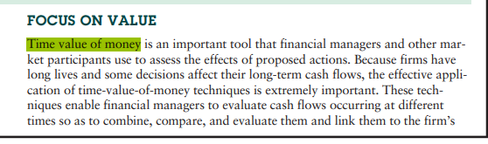

Explain the rationale for incorporating time value of money in financial decisions.

<https://www.economicsdiscussion.net/financial-management/time-value-of-money/32809>

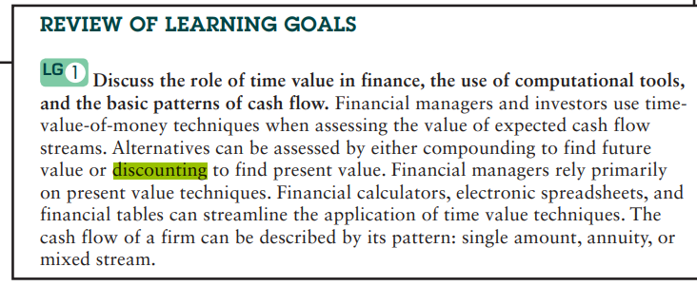

Describe the techniques of compounding and discounting.

<https://www.tutorialspoint.com/explain-compounding-technique-in-the-time-value-of-money>

<https://www.slideshare.net/KaranVerma79/discounting-techniques-of-time-value-of-money>

**Topic No. 2**

The following problems of your text book (Principles of Managerial Finance by Lawrence J. Gitman, 14th Edition)

Chapter 5, Time Value of Money

Problem Nos:

P5-4, P5-6, P5-8, P5-10, P5-14, P5-15, P5-17, P5-20, P5-22, P5-24, P5-25, P5-26, P5-27, P5-31, P5-33,

P5-37, P5-41, P5-43, P5-44, P-46, P5-50, P5-53, P5-56, P5-61 and Spread Sheet Exercise. The spread sheet exercise is to be solved using the MS Excel.

* These two parts of the assignment will carry a total 10 marks.
* You are allowed to submit handwritten or word docs for submission.
* You are to submit to my email: [mkashem@du.ac.bd](mailto:mkashem@du.ac.bd) by 26 November, 2021.